Practical No: 02
Aim:Cross-Website Functional Testing Using Selenium IDE Tool:
Selenium IDE Develop and execute a test suite for two different websites. Perform functional operations such as clicking links, filling forms, selecting dropdown options, and verifying displayed content. Analyze test results and generate execution logs.
REQUIREMENTS:
1) Selenium IDE extension on a browser.
2) A stable Internet connection.
STEPS:
1) Just google “Selenium IDE chrome” and click on the first link. Add the “Selenium IDE” extension to your browser.
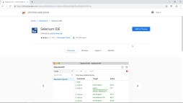
2) For testing, we’ll choose “redbus.in” as our first website. We’ll be checking some Selenium IDE Commands like assertText, verifyTitle, storeText, echo. Detailed info for several commands are provided at https://ui.vision/docs/selenium-ide .
• Now google “redbus.in”.
• Copy the URL of the page and open “Selenium IDE” extension:
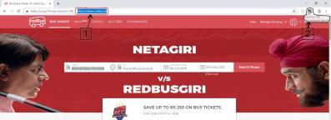• Now, Record a new test project in a new project:
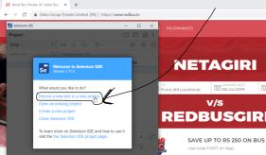• Name your project:
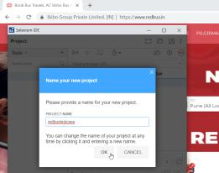
• Paste that URL here and click Start Recording:
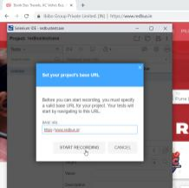
• A new tab will be opened, maximize that tab(this tab is your working tab for recording):
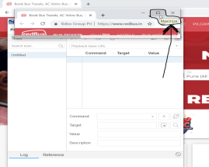
• Now we’ll make use of command verifyTitle.
(This command verifies title of the webpage and keeps on continuing the execution.) So anywhere on the window, do Right Click> select Selenium IDE> click Verify Title: 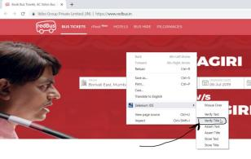• NOTE THAT each command is recorded:
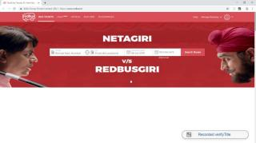• Now after filling the FROM, TO, ONWARD DATE, we proceed further by clicking on
Search Buses: (make sure not to do unnecessary clicks)
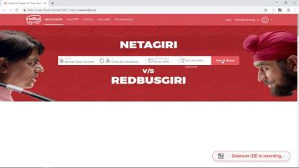• Now we’ll make use of command assertText.
(This command verifies particular text of the webpage and stops the execution of testcase if the match isn’t found.)
So, we want to make sure that our automated testcase chooses our specified Bus Provider.
To ensure that, here we do Right Click over the name of the bus
provider> then select Selenium IDE> and click Assert Text
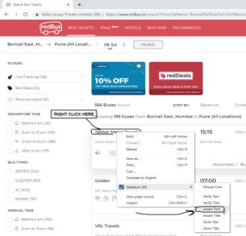
• Now we’ll make use of command storeText.
(This command stores the text value of page element into variable for future use.) Here we’ll store the price of the ticket.
So, we select the price> right click over it> select Selenium IDE> click Store Text : 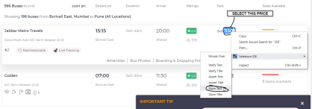• Now Selenium IDE will prompt us to enter the name of the variable in which that price will be stored:
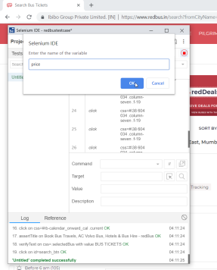
• After clicking OK, we can see how the target is automatically mapped to the css attribute of the page, and our price is stored:
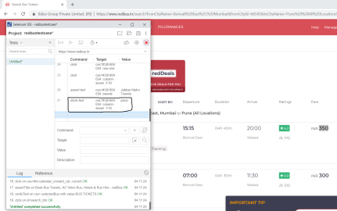• Now we’ll make use of command echo.
(This command is used to display text(comments, notes) and/or the stored value of variables in the log area of Selenium IDE.)
Here we’ll display the price of the ticket from the variable “price” that we stored during the use of storeText command.
To create a new command, we just click onto the next line and enter our
command:
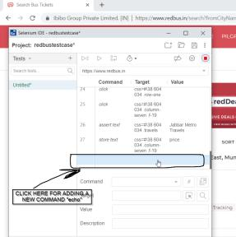
• We’ll enter the Command name echo, & Value ${price} because we are calling the created variable “price” from this command:
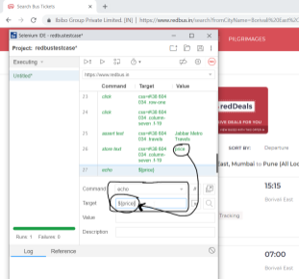
• Now we’ll Run current test:
• After the test gets completed, we can see the echo: 350 in the log area of Selenium IDE showing the output of the echo command.
Here we can see how 350 is stored in variable “price” by storeText command, and that variable is then called by the echo command, which is then returning the value fetched from the page:
3) Finish!
(Assert and verify commands are both useful for verifying condition match or not. The difference is that verify command will verify the condition and if it’s not match, it will give error message in Log area and the macro(testcase) continues to run. With the assert command, if the condition does not match then it will stop remaining macro(testcase) execution in the selenium IDE software testing tool.)

